JANUARY 2, 2022 MORNING WORSHIP 10:30 A.M.
2ND SUNDAY OF CHRISTMAS

GREETING THE GATHERED: The Love of Jesus Christ be with you!
ALL: And also with you!

THE WELCOME AND ANNOUNCEMENTS

PRELUDE The Prelude marks the beginning of worship.

Please observe silence as the Prelude begins.

THE CALL TO WORSHIP
Praise the LORD, O Jerusalem! Praise your God, O Zion!
For he strengthens the bars of your gates; he blesses your children within you.
He grants peace within your borders; he fills you with the finest of wheat.
---Psalm 147: 12-14

*THE HYMN OF PRAISE HYMNAL #485
“To God Be the Glory”

THE PRAYER OF CONFESSION:
Gracious God, our sins are too heavy to carry, too real to hide, and too deep to undo. Forgive what our lips tremble to name, what our hearts can no longer bear,
and what has become for us a consuming fire of judgment.
Set us free from a past that we cannot change;
open to us a future in which we can be changed;
and grant us grace to grow more and more in Your likeness and image,
through Jesus Christ, the light of the world. Amen.

THE SILENT PRAYER OF CONFESSION FOR OUR INDIVIDUAL SIN

THE DECLARATION OF FORGIVENESS
Believe the good news!
God did not send the Son into the world to condemn the world,
but in order that the world might be saved through him. --John 3:17
Friends, believe the good news of the gospel: In Jesus Christ you are forgiven. ALL: Thanks be to God!

THE FIRST READING: Jeremiah 31: 7-14 (Pew Bible OT pg. 734)

THE ANTHEM

THE PRAYER FOR ILLUMINATION

THE LESSON: John 1: 10-18 (Pew Bible NT pg. 91)

THE SERMON: “Grace and Truth” Dr. Rev. Gregory Goodwiller

PRAYERS OF THE PEOPLE

*AFFIRMATION OF FAITH: THE APOSTLES’ CREED
I believe in God the Father Almighty, Maker of heaven and earth,
And in Jesus Christ his only Son our Lord; who was conceived by the Holy Ghost,
born of the Virgin Mary, suffered under Pontius Pilate, was crucified, dead, and buried;
he descended into hell; the third day he rose again from the dead;
he ascended into heaven, and sitteth on the right hand of God the Father Almighty;
from thence he shall come to judge the quick and the dead.

I believe in the Holy Ghost; the holy catholic church; the communion of saints;

the forgiveness of sins; the resurrection of the body; and the life everlasting. Amen.

THE CHARGE AND BENEDICTION

*THE POSTLUDE

*All Who Are Able Please Stand

WELCOME & INVITATION

This church welcomes you, no matter who you are,
where you come from, or why you are here.
We are Christ’s people,
and this is Christ’s place with its doors open wide.
If you are passing through, Godspeed;
if you are looking for a home, stay here;
if you need instruction, learn from us as we learn from you.
We invite visitors to join us, but most of all, to return often.

We are so glad you are here.

FOR YOUR INFORMATION: The RPC Office is open Monday through Wednesday 9:00 AM – 4:00 PM, & Thursday, 9:00 AM – 12:00 Noon
RPC Staff
Rev. Dr. Jody Hill | Pastor Jennifer Huddleston | Choir Director Lynn Hill | Administrator & Pianist

Scan with your smart phone for our Website & Virtual Tour

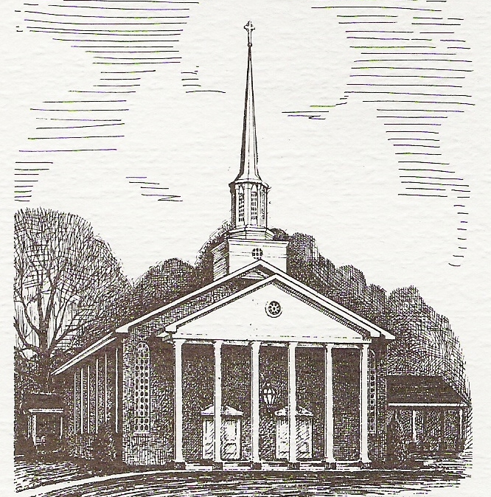

RIPLEY PRESBYTERIAN CHURCH
A Heart for Christ & Community Since 1837
Worship Service: 10:30 a.m.

Rev. Dr. Jody Hill | Pastor

Phone: 662-837-3765 (Office)
Mail: P.O. Box 556 Ripley, MS 38663
302 West Cooper Street

www.ripleypresbyterianchurch.com

Rev. Dr. Gregory Goodwiller, Executive Presbyter of the Presbytery of St. Andrew will bring our message today in Rev. Dr. Jody Hill’s absence. We are very grateful for his willingness to lead our worship today—please join us in welcoming him to RPC.

Notes of Thanks…
“Dear RPC Family,
Thank you so very much for the gracious Christmas gift you gave me. It is such a joy for my family and me to serve with you in ministry. As often as I think of our Church family, I give thanks to God for each and every one of you.
Merry Christmas and Happy New Year,

Jody”

“Dear RPC Family,
Thank you for the Christmas gift—it was so very generous, and so appreciated.
I love my job and I love our church—I consider myself very blessed to be serving in this capacity.
Love to all,
Lynn”

PRAYER LIST FOR IMMEDIATE NEEDS
Jimmy Gaillard, Judy Austin, Ann Wigington, Margaret & Kent Montgomery, Tom Muir,
Jack Jones, Brenda Brown, Charles Bryant, Brent Henderson, Sherry Hill, Danny Wilbanks, Lorenzo Medford, Gail Allensworth, Ali Rae Barkley, Adrienne Phillips, Jamie Wall,
Helen Beavers, Tate Daniel, Maxine Tomlinson, Calvin Austin, Ticer Brown, Bradley Childs,
Leah & Miles Harrell.

Our Deepest Sympathies to…
The family of Opal LaBarreare

Our Homebound, Assisted Living & Nursing Home Residents
Laron Shannon, Jean Ketchum, Carolyn Caviness, Johnny Cappleman, Billie Pickens,
Jimmy & Judy Hines Hopper.

RPC Weekly Financial Update RPC Weekly 2021 Budget: $2,710.97
Offering Received 12/26/21: $3,840.00

COMING UP….
Tuesday, January 11 | RPC Presbyterian Women Bible Study | 10 AM

RPC MISSION FOCUS FOR JANUARY 2022
PRESBYTERIAN DISASTER ASSISTANCE / TORNADO RELIEF
Total Collected as of 12/26/2021: $25.00

RPC has designated the mission focus for January to providing assistance
to those who have suffered from the devastating and horrific tornadoes of December 10, 2021.

Please make checks payable to Ripley Presbyterian Church, note “Tornado Relief” in the memo line, and we will send one check as a congregation to
the Presbytery of St. Andrew on February 1, 2021.

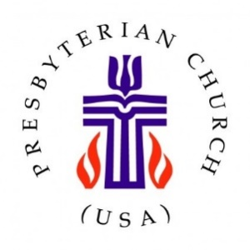

A Message from Presbytery of St. Andrew | Tornado Relief
Many of you have seen the devastating news coming out of western Kentucky and beyond, after last Friday's tornadoes. In lieu of providing tangible goods or coordinating volunteers at this early stage, the Missions Committee invites individuals and congregations to send financial contributions to the presbytery office.

By receiving money here at our presbytery office, we hope to remain nimble as needs evolve and the long-term recovery picture becomes clearer. Currently, recipients might include Presbyterian Disaster Assistance, direct support to First Presbyterian Church in Mayfield, KY (or Western Kentucky Presbytery), and Mercy Chefs, a faith-based organization that is currently on the ground in Mayfield feeding residents and first responders.

We also wanted to pass along the following, which is part of an update shared on the Presbytery of Western Kentucky's website on December 14:
"The tornadoes of December 10, 2021, completely destroyed the Mayfield church and almost the entire downtown, though there were no casualties to church members or their property. However, the property of some of the church members in Princeton, was either damaged or destroyed and other areas of western Kentucky such as Bowling Green and Dawson Springs experienced both significant loss of life and property throughout their communities.
…Presbyterian Disaster Assistance (PDA) will be in the area assessing needs and the ways churches and individuals can assist. They plan to visit all areas affected by the tornadoes.

